

Channabasaveshwara Institute Of Technology
(Affliated to VTU ,Belgum&Approved by AICTE,New Delhi)
(ISO 9001:2015 Certified Institution)
NH 206(B.H.Road),Gubbi,Tumkur -572216,Karnataka

Presented by:
NAME:Likhitha.H.K
USN:2024BECS95
BRANCH:CS
SEC:”B” SEC
Sub:SELF LEARNING TOPIC(CHEMISTRY)
TYPES OF ELECTROCHEMICAL SENSORS

Under the guidance of:
Dr.Umesh Laddi
Department of chemistry


CONTENT

- Introduction
- Definations
- Types
- Types Explanation
- Conclusion

ELECTROCHEMICAL SENSORS:
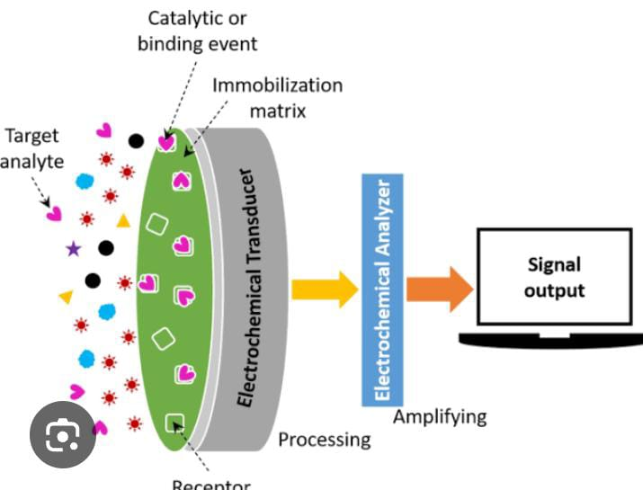

Electrochemical sensors detect chemical substances by converting chemical reactions into electrical signals .

The Main Type Of Electrochemical Sensors Are Include:

- Potentiometric Sensors:
- Amperometric Sensors:
- Conductometric Sensors:
- Impedimetric Sensors:
- Voltammetric Sensors:
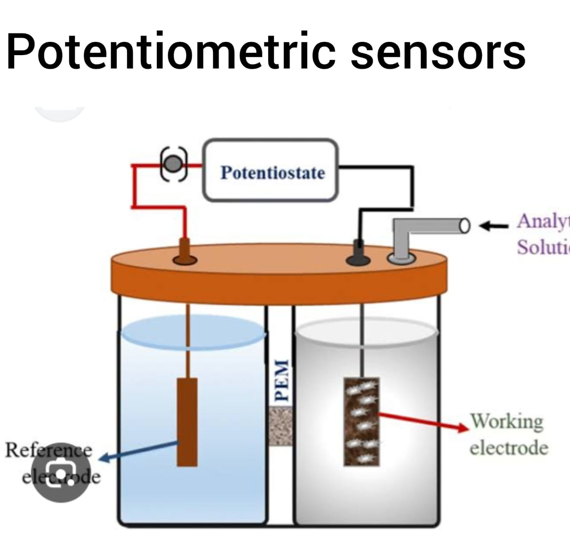
- Potentiometric sensors

Measure the potential difference between a reference electrode and an indicator electrode without drawing current .
Commonly used in pH meters and ion -selective electrodes.

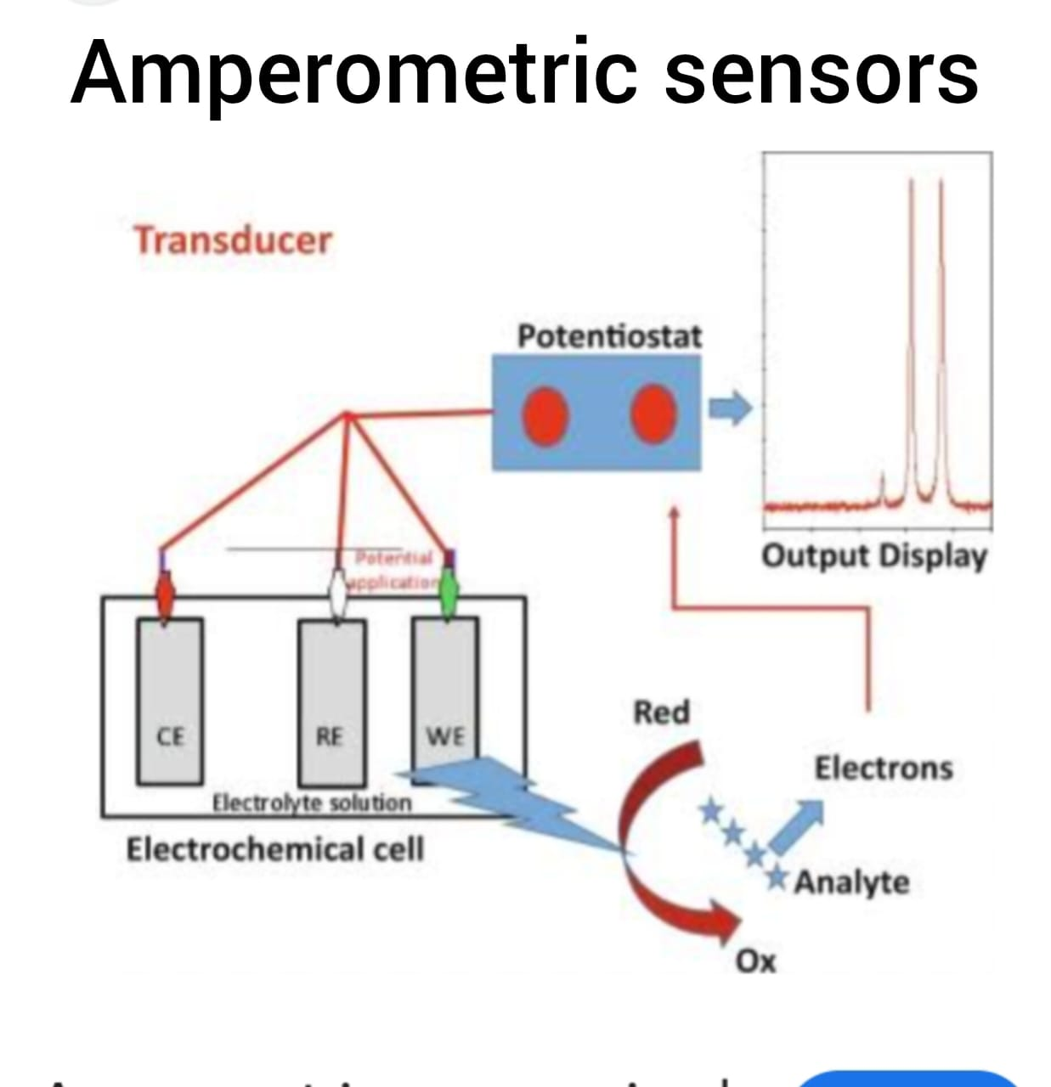
2) Amperometric Sensors

Measure the current produced by the oxidation or reduction of an analyte at a working electrode as a function of applied potential .they are often used in glucose sensors and oxygen detectors .

3) Conductometric Sensors:
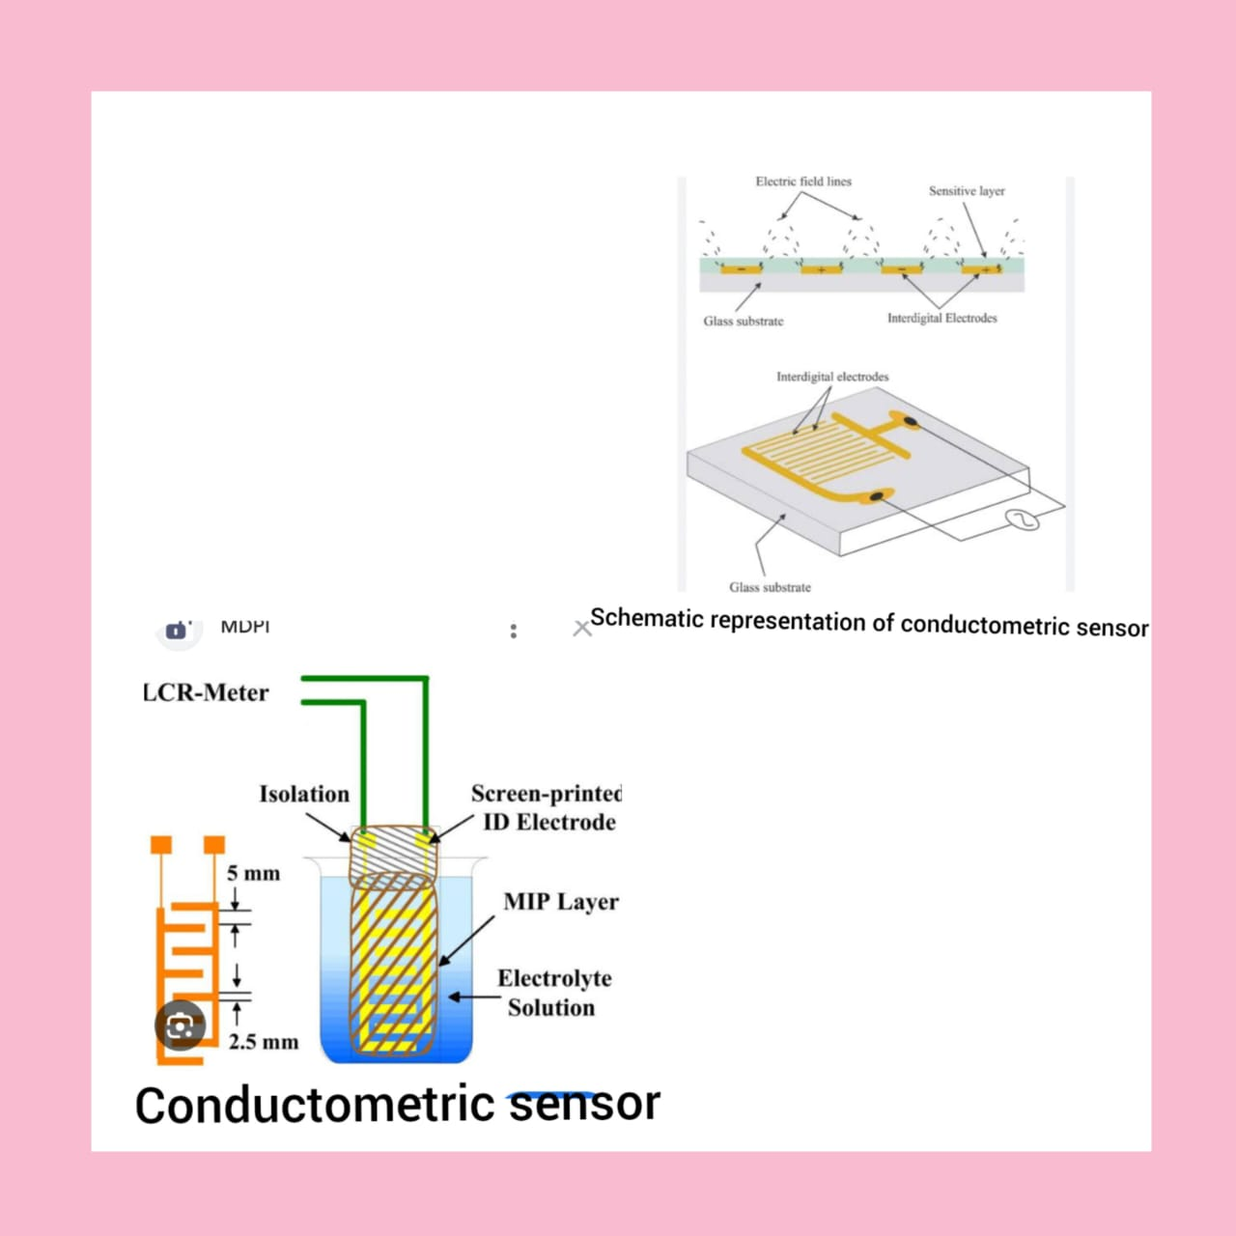

Detect changes in the conductivity of a solution as a result of a chemical reaction .these are often used for gas sensing , such as for ammonia or corbon dioxiode.

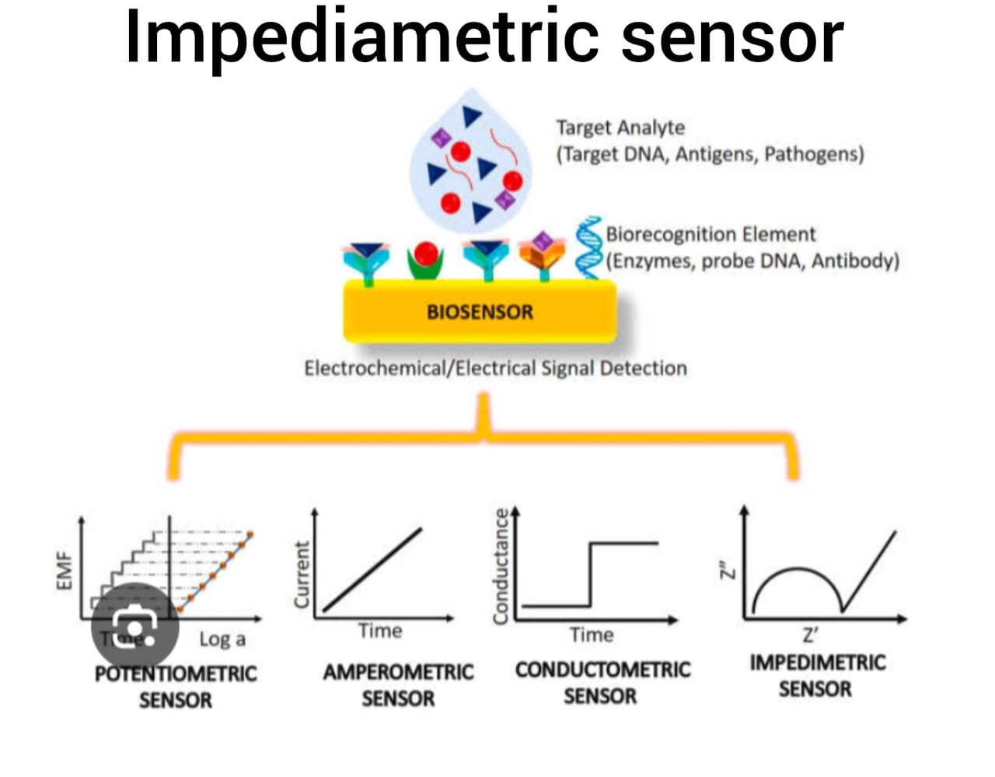
4) Impedimetric Sensors:

Measure impendence changes in the presence of an analyte .they are usefull in biological sensing application ,such as detecting pathogens or DNA.

5) Voltametric Sensors:
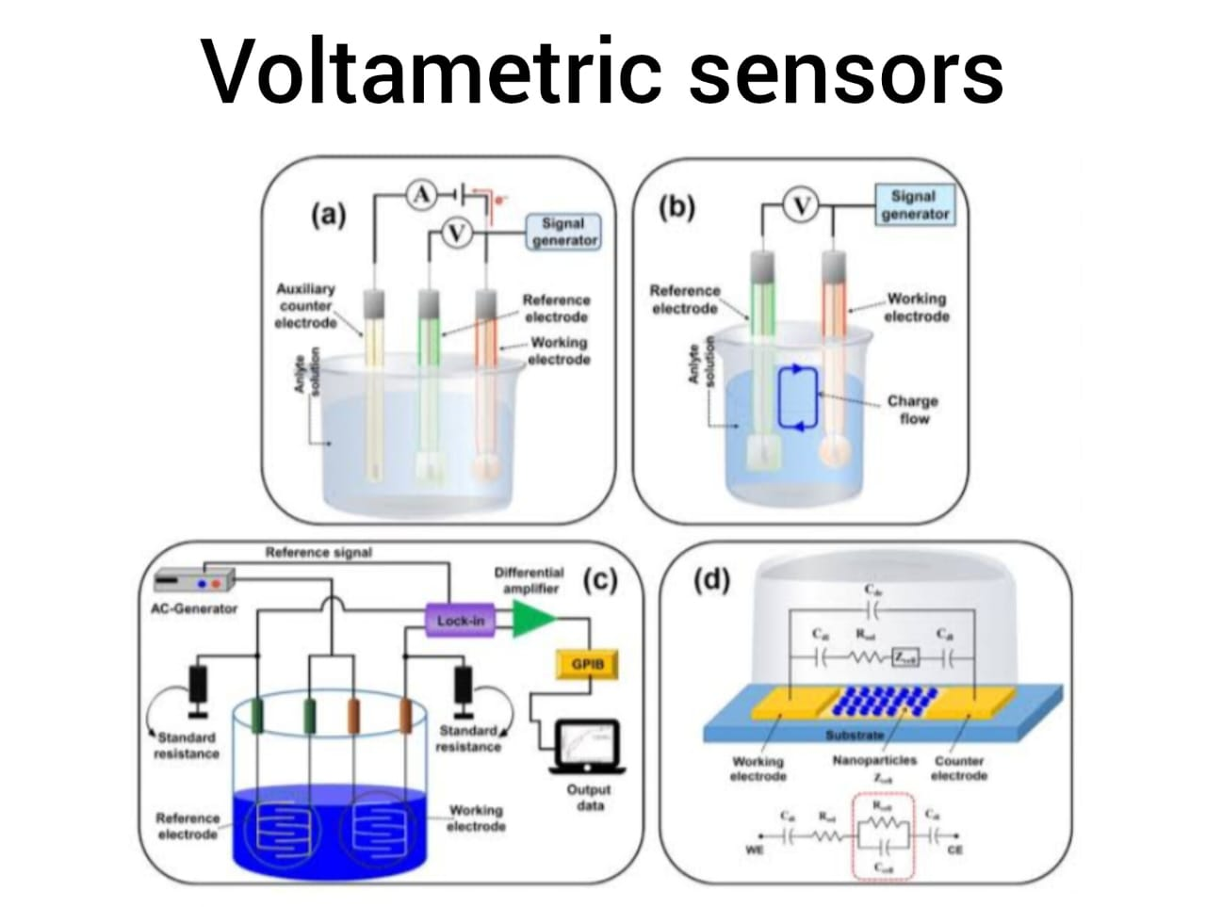

Involve applying a varying voltage and measuring the current response to detect analytes .Cyclic voltammetry is a common method within this chatagory, used for studying redox-active species .
Each type offers distinct advanteges based on sensitivity,selectivity,and compabality with sepefic applications.



